**MACHINE PROBLEM NO. 5**

Screenshots and Proof of Testing

**CODE:**

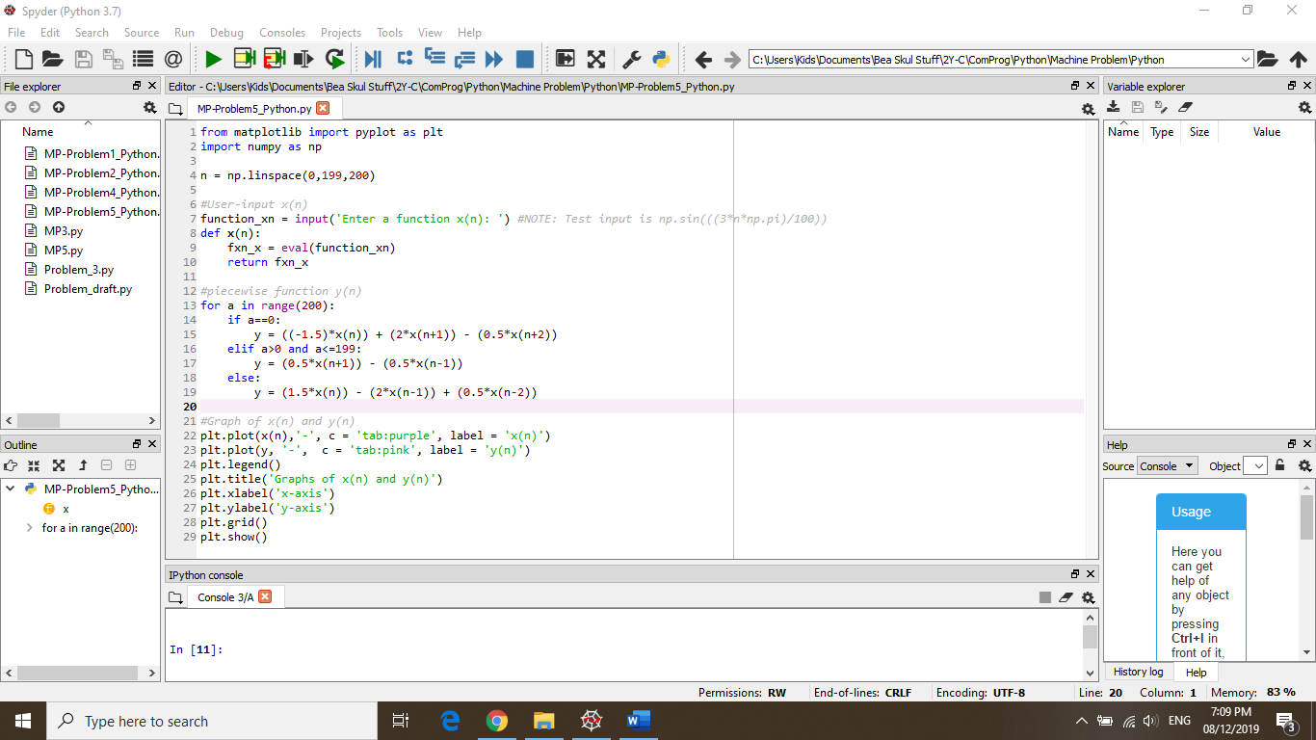

**TEST:** *where x(n) = np.sin(((3*n*np.pi)/100))*

